SEASALTER CROSS WI
PROPOSED OUTING TO THE ROYAL HOSPITAL CHELSEA
WEDNESDAY 10TH JUNE 2026

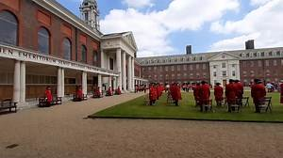
Leaving Seasalter at 8.00 a.m
Returning about 6.00 p.m.
Cost includes coach and 1.5 hour tour led by a Chelsea Pensioner:
£35 members
£45 guests
£10 non returnable deposit and balance to be paid by 1st May 2026.

In addition
if you wish to eat here, there is a family bakery and café located within the Soane Stable Yard which is the starting and finishing point of the tour. They make everything fresh from scratch everyday so we are pretty sure you will all enjoy their food and service.
You can all have coffee / tea / drinks / pastries on arrival prior to the tour if time. After the tour, if you wish to have lunch on site, they have a very popular lunch deal that is called "Lunch with Love".
People can choose from an impressive selection of savouries (pizza, sandwiches, wrap, quiches to name just a few) plus a side salad (we have 5 different options daily) plus a hot / cold or soft drink for £12.50 per person or including a glass of wine of beer for £16.
We should have good weather in June and the outdoor space is lovely and perfect for all to have a memorable lunch after the tour.
Please let us know if you would like to have lunch here so that we can book tables and whether you would like the “Lunch with Love” option payable on the day.

Nearby is the Chelsea Embankment, Battersea Park or other attractions.

